URL: https://adityabirlahospital.com/doctors/ent-doctors-in-pune

Meta Title: Best Ear Nose Throat Ent Specialists In Pimpri Chinchwad | ABMH

Meta Description: Find the best ENT specialists in Pimpri Chinchwad at Aditya Birla Hospital. Expert care for all your ear, nose, and throat needs. Book your appointment today!

Best Ent Doctors In Pimpri-Chinchwad Pune
ENT doctors, also known as otolaryngologists, specialize in diagnosing and treating conditions related to the ear, nose, and throat. Their expertise spans managing allergies, treating hearing loss, and addressing sinus disorders, among other ENT concerns.

Our Team Of ENT Doctors
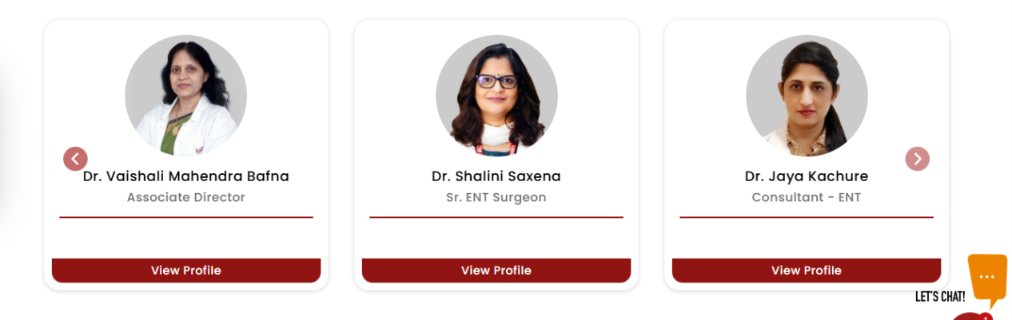
At Aditya Birla Memorial Hospital, our ENT specialists are committed to delivering exceptional care to ensure your ear, nose, and throat health is well managed. As a leading ENT Hospital in Pimpri Chinchwad Pune, we offer comprehensive services in a state-of-the-art facility. Whether you’re in need of a routine check-up or specialized treatment for a complex condition, our team provides tailored, compassionate care designed to meet your unique needs.
If you’re looking for experienced ear doctors or throat specialists in Pimpri, Pune, our hospital offers access to some of the best ENT doctors and surgeons in the region, ready to support you with exceptional expertise.

Our ENT Doctors Treat the Following Conditions:

Sinusitis Treatment
Medical and surgical management for chronic or acute sinus infections.

Hearing Loss Treatment
Diagnosis and treatment for conductive, sensorineural, and mixed hearing loss, including hearing aids and surgical options.

Tonsil & Adenoid Surgery
Surgical removal of tonsils or adenoids for chronic infections or breathing problems.

Allergy Management
Diagnosis and treatment for common ENT-related allergies, including nasal allergies and asthma management.

Snoring & Sleep Apnoea Treatment
Treatment options for snoring and obstructive sleep apnoea, including CPAP therapy and surgical interventions.

Throat Disorders Treatment
Care for voice, swallowing, and throat disorders, including vocal cord issues and laryngitis.

Vertigo & Dizziness Management
Diagnosis and treatment for balance disorders and dizziness, including vestibular rehabilitation.

Ear Infections & Surgery
Medical and surgical treatment for chronic ear infections, including tympanoplasty and myringotomy.

Nasal Congestion & Deviated Septum
Treatment for chronic nasal congestion, including septoplasty and endoscopic sinus surgery.

Facial Nerve Treatment
Management of facial nerve disorders such as Bell’s palsy.

Thyroid & Parathyroid Disorders
Diagnosis and surgical treatment for thyroid and parathyroid conditions affecting the neck and throat.

Paediatric ENT Care
Specialized care for children, including treatment for ear infections, tonsillitis, adenoid problems, speech and language development issues, and paediatric sleep apnoea.

How Do I Find an ENT Doctor Near Me in Pune?

Looking for the best ear nose throat doctor near you in the PCMC area? You can reach us easily from many areas nearby.

Nearby Locations:

Hinjewadi, Wakad, Baner, Aundh, Pimple Saudagar, Bhosari, Ravet, Chinchwad Gaon, Tathawade, Nigdi, PCMC, Pimpri, Moshi, and Chakan

